Smart Healthcare Appointment and Resource Management System



Project Sponsor
Prof. David Pitts, Rivier University

Submitted by
Sravan Kumar Reddy Pergu _ 0104363
Spring-2026 _ RIVIER UNIVERISTY

USECASE DIAGRAM

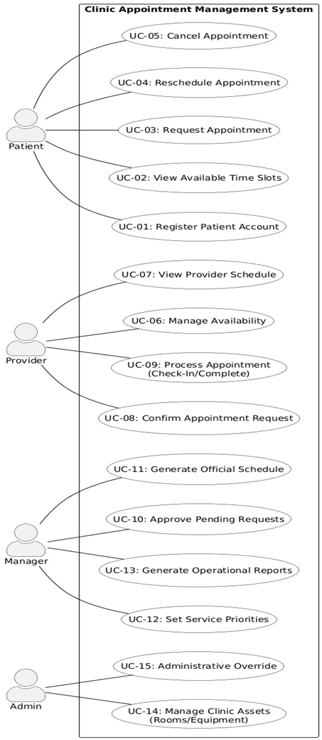

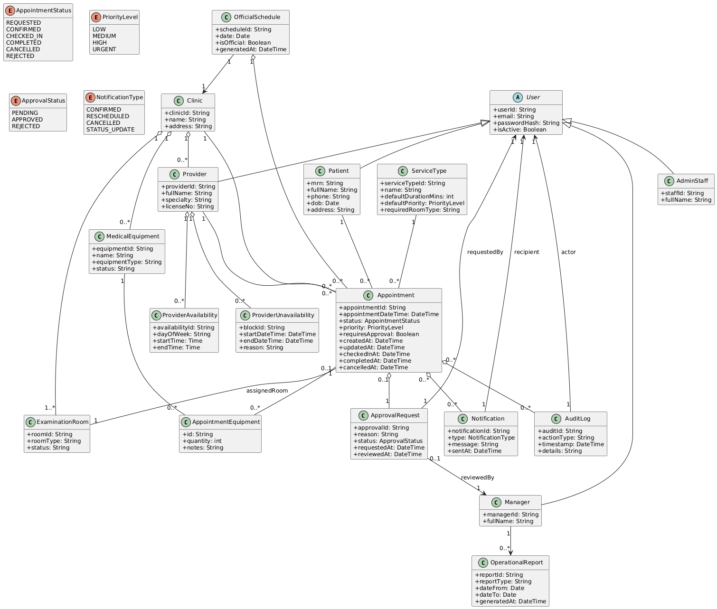
CLASS DIAGRAM

OBJECT DIAGRAM

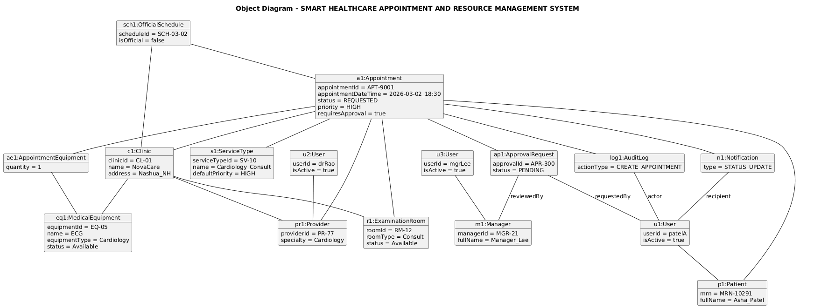

SEQUENCE DIAGRAMS

- REQUEST APPOINTMENT

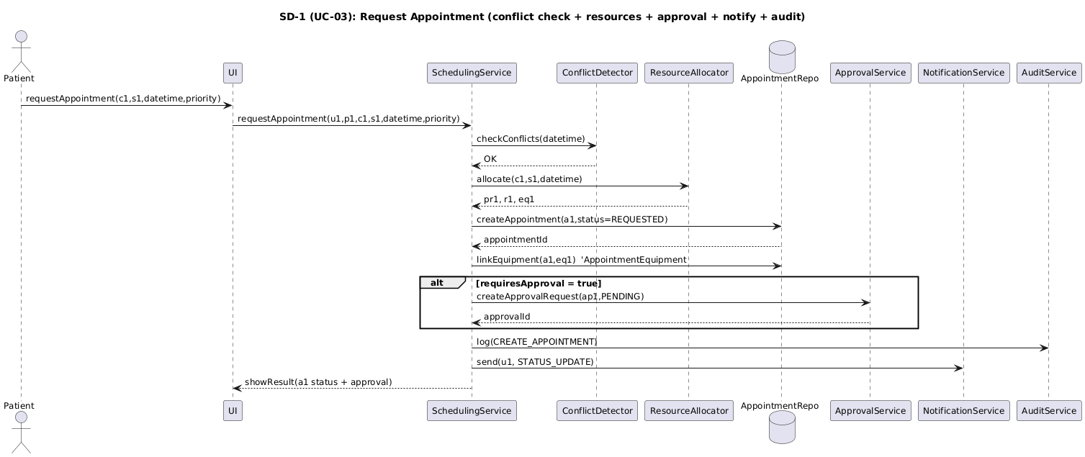

- APPROVE PENDING REQUESTS

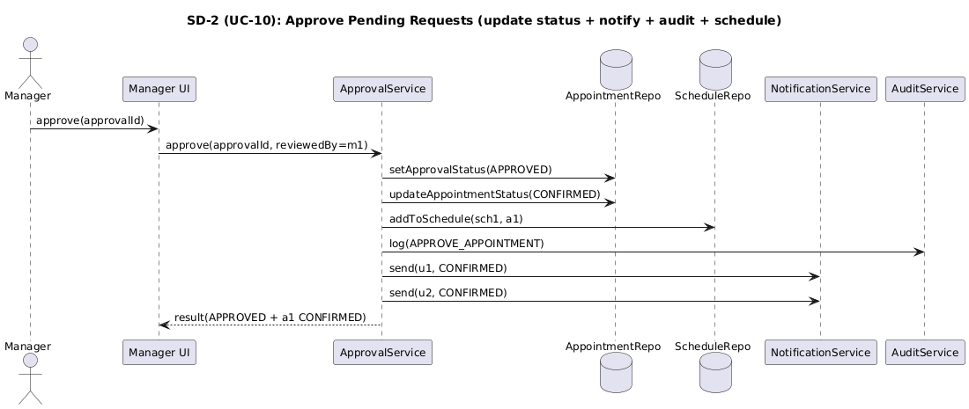

Derivation of Structural and Behavioral Models

1. Derivation of the Structural Model (Class Diagram)
The class diagram was derived directly from the functional use cases.
The nouns identified in the use case descriptions were converted into domain classes.
- The actors Patient, Provider, Admin Staff, and Manager were modeled as subclasses of the abstract class User to support role-based access control.
- The use case UC-03 Request Appointment led to the creation of the Appointment class with attributes such as status, priority, requiresApproval, createdAt, checkedInAt, completedAt, and cancelledAt to represent the appointment lifecycle.
- The requirement to prevent double booking resulted in the inclusion of ProviderAvailability and Provider Unavailability classes.
- The need to manage clinic assets (UC-14) resulted in the classes Clinic, ExaminationRoom, and MedicalEquipment.
- Because appointments may require medical equipment, a many-to-many relationship between Appointment and MedicalEquipment was implemented through the association class AppointmentEquipment.
- The use case UC-10 Approve Pending Requests resulted in the creation of the ApprovalRequest class linked to Appointment and Manager.
- The requirement to log actions resulted in the inclusion of the AuditLog class.
- The requirement to notify users resulted in the Notification class.
- The use case UC-11 Generate Official Schedule resulted in the OfficialSchedule class.
- The use case UC-13 Generate Operational Reports resulted in the OperationalReport class.
The structural model was refined iteratively to ensure that all use cases were supported by appropriate classes and relationships.

2. Derivation of the Object Diagram
The object diagram was created using a specific scenario from UC-03 Request Appointment where a high-priority after-hours appointment requires managerial approval.
The object diagram demonstrates:
- An instance of Appointment (a1) in REQUESTED state.
- An instance of ApprovalRequest (ap1) in PENDING state.
- Allocation of a specific ExaminationRoom (r1).
- Association with specific MedicalEquipment (eq1).
- A generated Notification (n1).
- An AuditLog (log1) entry recording appointment creation.
- An OfficialSchedule (sch1) instance that groups appointments by date and clinic.
This diagram validates that the structural relationships defined in the class diagram work correctly in a real-world scenario.
3. Derivation of the Behavioral Model (Sequence Diagrams)
The sequence diagrams were developed directly from the main flow steps in the use case descriptions.
For UC-03 Request Appointment, the sequence diagram models:
- User authentication.
- Conflict detection to prevent double booking.
- Resource allocation (provider, room, equipment).
- Appointment creation.
- Approval request generation (if required).
- Audit logging.
- Notification sending.
For UC-10 Approve Pending Requests, the sequence diagram models:
- Manager authentication.
- Retrieval of pending approval requests.
- Approval decision.
- Update of appointment status.
- Addition to official schedule.
- Notification to patient and provider.
- Audit logging.
Each message in the sequence diagrams corresponds to responsibilities defined in the class diagram, ensuring traceability between the functional, structural, and behavioral models.

